
WEST Support Card – Sitting Screener
Step 1

- Click ‘Quick Links’ in the top-right corner of the Talk training website www.talktraining.co.uk
Step 2
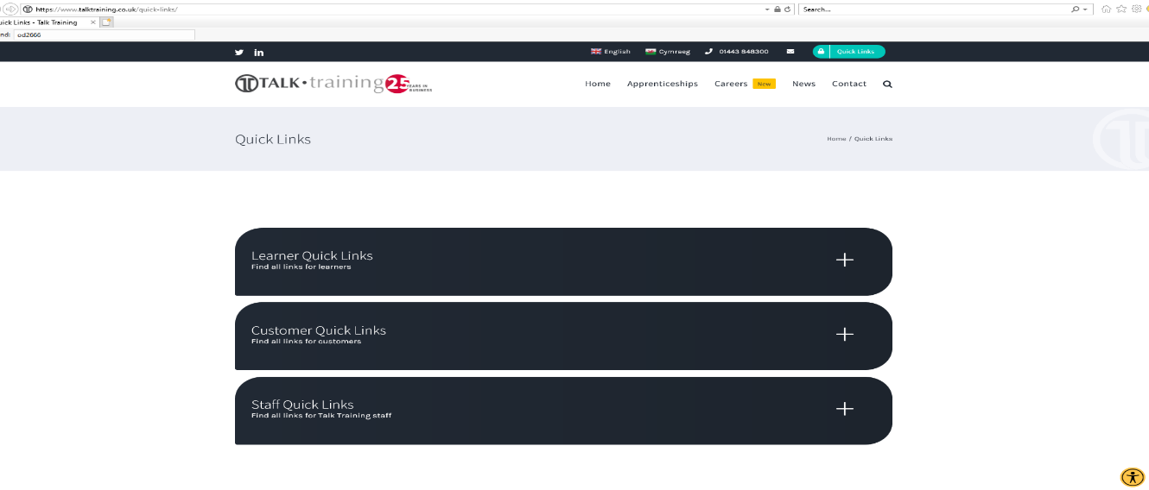
- Within the Quick Links page, click ‘Learner Quick Links’ to open the drop-down menu for learners

Step 3
- From the Learner Quick Links menu, click the ‘Wales Essential Skills Toolkit’ option
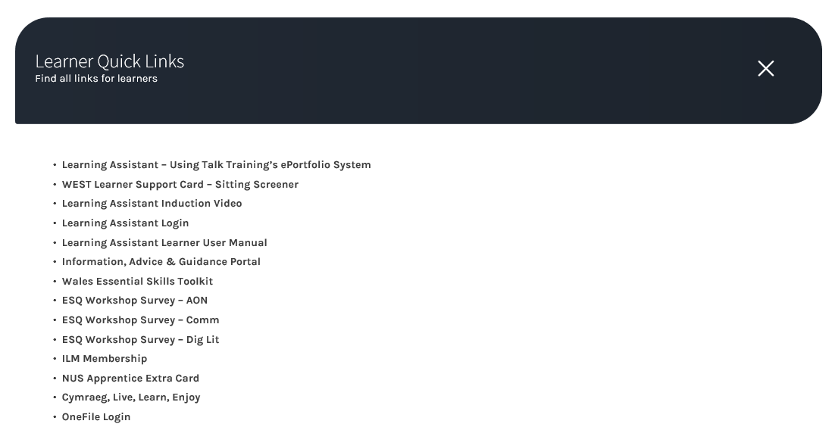

Step 4
- Click on ‘Take a screener’


Step 5
- After reading the short explanation of what a screener is click on Next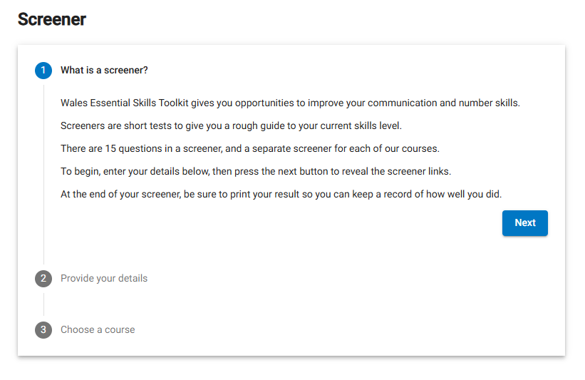
Step 6
- Complete the ‘Provide your details’ boxes and then click on Next:
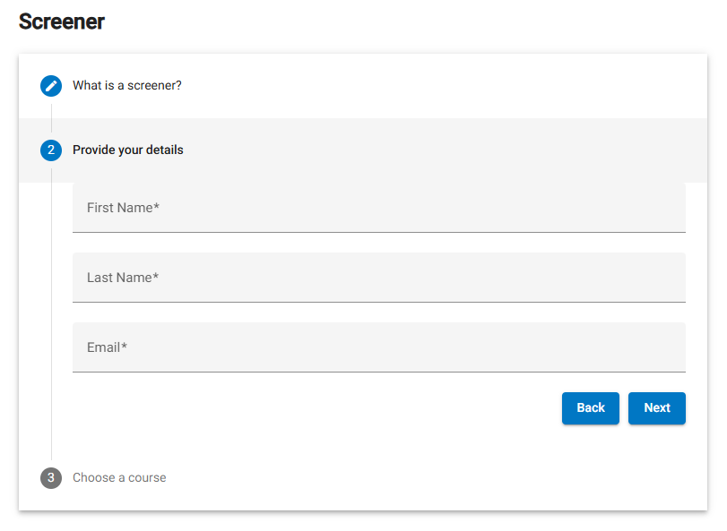

Step 7
- Click on the ‘Start’ button for the course you are doing the screener for – please note you are required to complete all of the courses.
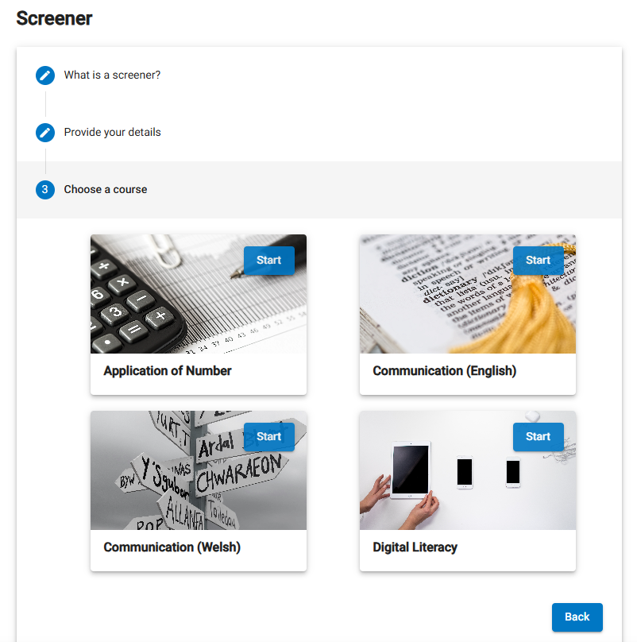
The screener will launch and depending on which course you are ding will look something like this. Once you have selected your answer click on the arrow on the right hand side to go to the next question.
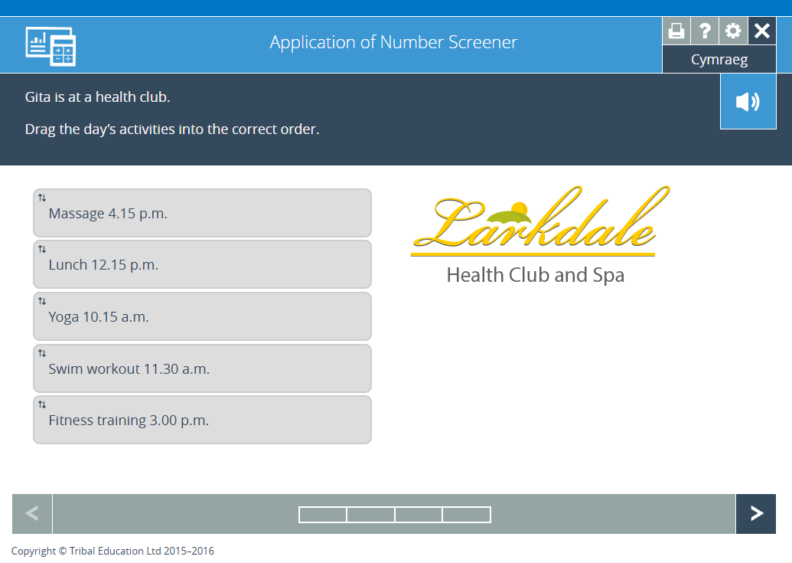
Step 8
- Once you have finished the questions you will see this screen, or something similar. Click on the ‘X’ to close this creen and return to select your next course.
